**Question 1**

Water sample taken an subsamples were piked with radioactive bicarbonate and incubated at different light levels uptake was looked at.

**Question 1A**

Plot productivity as a function of light

**Question 1B**

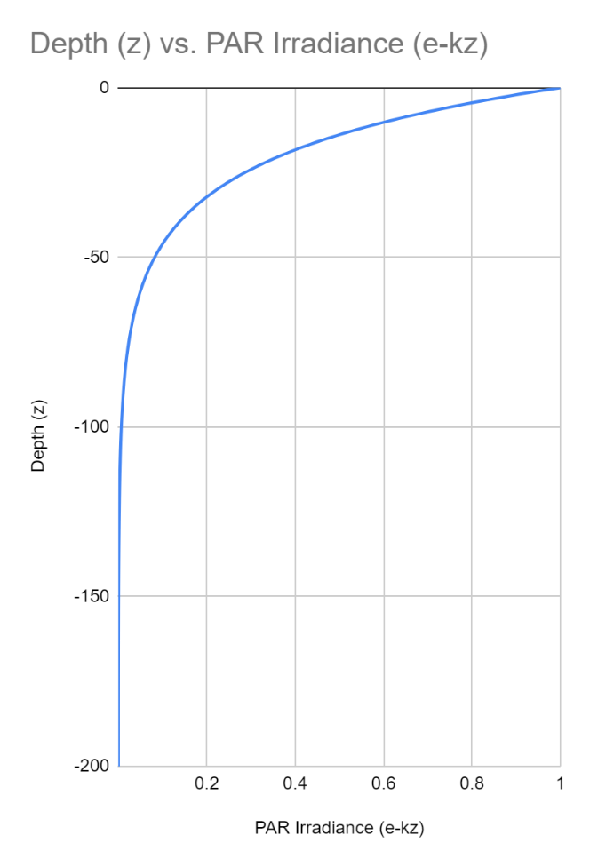

**Question 1C**

|  |  |  |  |  |  |
| --- | --- | --- | --- | --- | --- |
|  | Depth (z) | **PAR Irradiance (e-kz)** |  | **I** | **Productivity** |
| 1 | 0 | 730.000000 |  | 0 | 0 |
| 0.9512294245 | -1 | 694.397480 |  | 1 | 0.001953877583 |
| 0.904837418 | -2 | 660.531315 |  | 2 | 0.003884447518 |
| 0.8607079764 | -3 | 628.316823 |  | 3 | 0.005791920197 |
| 0.8187307531 | -4 | 597.673450 |  | 4 | 0.007676504307 |
| 0.7788007831 | -5 | 568.524572 |  | 5 | 0.009538406847 |
| 0.7408182207 | -6 | 540.797301 |  | 6 | 0.01137783314 |
| 0.7046880897 | -7 | 514.422305 |  | 7 | 0.01319498684 |
| 0.670320046 | -8 | 489.333634 |  | 8 | 0.01499006996 |
| 0.6376281516 | -9 | 465.468551 |  | 9 | 0.01676328286 |
| 0.6065306597 | -10 | 442.767382 |  | 10 | 0.01851482428 |
| 0.5769498104 | -11 | 421.173362 |  | 11 | 0.02024489136 |
| 0.5488116361 | -12 | 400.632494 |  | 12 | 0.02195367961 |
| 0.5220457768 | -13 | 381.093417 |  | 13 | 0.02364138299 |
| 0.4965853038 | -14 | 362.507272 |  | 14 | 0.02530819384 |
| 0.4723665527 | -15 | 344.827584 |  | 15 | 0.02695430297 |

**Question 1D**

**Question 1E**

**Question 2**

Looking at the effects of micro zooplankton grazing impact on phytoplankton. Microplankton was removed and added in at certain percentages (seawater)

**Question 2A**

|  |  |  |  |
| --- | --- | --- | --- |
| Fraction of Seawater | Initial Chl-a | Final Chl-a | Growth Rate r |
| 0.1 | 0.035 | 0.088 | 0.921988753 |
| 0.1 | 0.035 | 0.081 | 0.839101093 |
| 0.1 | 0.035 | 0.078 | 0.801360765 |
| 0.25 | 0.088 | 0.172 | 0.670157662 |
| 0.25 | 0.088 | 0.16 | 0.597837001 |
| 0.25 | 0.088 | 0.193 | 0.785353374 |
| 0.5 | 0.175 | 0.321 | 0.606655149 |
| 0.5 | 0.175 | 0.255 | 0.376477571 |
| 0.5 | 0.175 | 0.298 | 0.532307513 |
| 0.75 | 0.263 | 0.385 | 0.381089302 |
| 0.75 | 0.263 | 0.362 | 0.31949018 |
| 0.75 | 0.263 | 0.395 | 0.406731733 |
| 1 | 0.3 | 0.4 | 0.287682072 |
| 1 | 0.3 | 0.43 | 0.360002734 |
| 1 | 0.3 | 0.45 | 0.405465108 |

**Question 2B**

*Q These values are confusing

**Question 2D**

Light at 10 meters

|  |  |  |
| --- | --- | --- |
|  | **Growth Rate** |  |
| My Estimate (Problem 1) | 0.06368602676 |  |
| Problem 2 | ~0.360002734 |  |

Per day growth rate

**Question 3**

Looking at a phytoplankton bloom, iron rich has more phytoplankton biomass

|  |  |  |  |
| --- | --- | --- | --- |
| **Abundance of cells** | **gC** | **gC growth** | **micrograms of carbon** |
| 2000000 | 0.00000000000000100000 | 0.000000002 | 0.002 |

Growth is controlled by

Nutrient supply

Temperature

Light level

pH

**Question 4**